Computer Vision

CS – GY – 6643

Histogram Equalization Report

Rhuthvik Dendukuri – rd3377

2/13/2024

Table of Contents

|  |  |
| --- | --- |
| Contents | Page No. |
| A1) Histogram Equalization | 3 - 9 |
| **Histogram Equalization** | 3 |
| **Histogram Equalization on “People.png”** | 4 |
| **Histogram Equalization Discussion** | 5 |
| **Histogram Equalization CDF Differences** | 5 |
| **Histogram Equalization Reapplication** | 6 |
| **Histogram Equalization on Different Image** | 8 |
| **A2) Otsu Image Thresholding** | 10 - 16 |
| **b2_a image** | 10 |
| **b2_b image** | 12 |
| **b2_c image** | 14 |
| **Results** | 16 |
| A3) Creative Part | 19 - 22 |
| **Histogram matching** | 19 |
| Experiments | 19 |
| Experiment 1 : Low Contrast Image to High Contrast Image | 20 |
| Experiment 2 : High Contrast Image to Low Contrast Image | 21 |

### A1) Histogram Equalization

1. **Include a brief introduction and description of how histogram equalization works.**

**Histogram Equalization:**

Using a technique called histogram equalization, one can improve an image’s contrast by dispersing the intensity values throughout the whole range. The fundamental concept behind histogram equalization is to adjust the pixel intensities so that the image’s histogram’s cumulative distribution function (also known as the CDF) is represented as a linear function. Through this technique, the intensity values are effectively spread out, resulting in a more uniformly distributed histogram for the image.

Process of Histogram Equalization:

* 1. Compute Histogram: As an image is given as an input, create a histogram of the input that gives the frequency of pixels at each pixel intensity.
  2. Compute PDF: Once histogram is computed, the frequencies are normalized, i.e., each frequency at a pixel intensity is divided by total count of pixels.
  3. Compute CDF: With the PDF values, calculate the cumulative sum of counts of pixels. The range of this CDF is from 0 to total number of pixels. Then, calculate the normalized CDF values.
  4. Histogram Equalization Enhancement: Each pixel at a particular intensity will be denormalized again, i.e., the CDF of that intensity is multiplied by 255 and placed in the resulting equalized image.

1. **Show people.png before and after histogram equalization, and the corresponding histograms (PDFs).**

“**people.png**” before the histogram equalization and PDF:

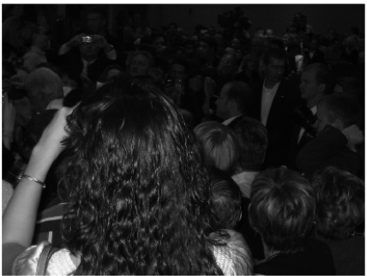 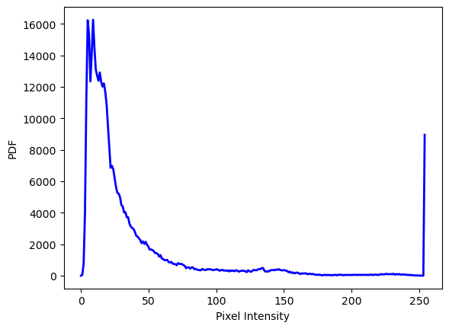

“**people.png**” after the histogram equalization and PDF:

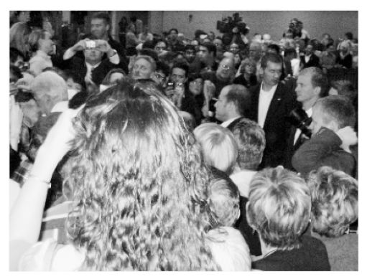 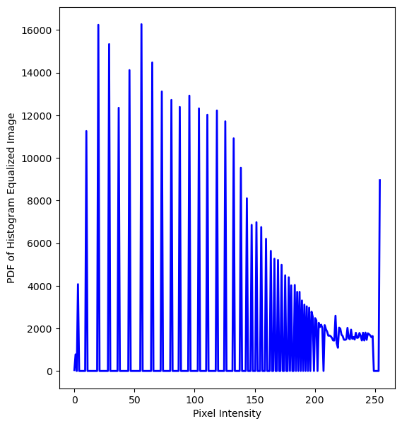

1. **Discuss how the image and histogram have changed, and connect it back to your description.**

Change in the image:

The original image has a darker shade to it. Once the histogram equalization is applied on the image, the intensity level has an approximately equal probability. The resultant image is now brighter. We can say that the contrast is increased which makes the darker places of the image brighter.

Change in the Histogram:

Initially, the histogram is biased on the left side and then on the rightmost end. This means that there are a lot of dark pixels and very few light pixels. The histogram is not uniformly distributed across the pixel intensity range.

After the histogram equalization is applied on the input image, the pixel intensities have been spread equally along the pixel intensity range. The resultant histogram is uniformly distributed. This is relatively more uniform than the input image’s histogram.

1. **Show the cumulative distribution function before and after histogram equalization in a side-by-side figure. Describe what you see. Explain the shape of each CDF and relate it back to image contrast and intensity histogram shape.**

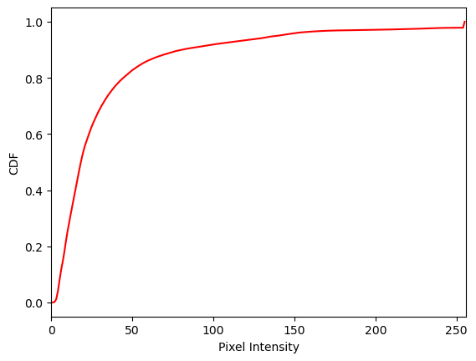 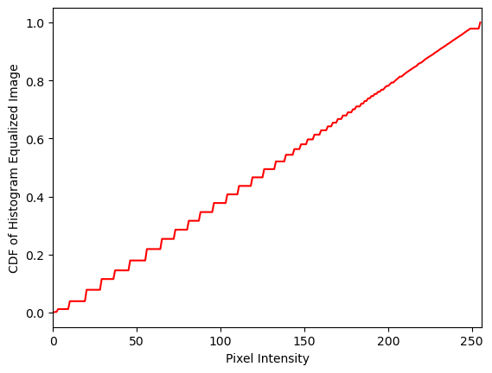

The Cumulative Distribution Function (CDF) represents the cumulative probability of pixel intensities in an image.

**Before Histogram Equalization:**

**Shape of CDF:**

In the input image, the CDF tends to start from 0 and gradually increases. The shape is influenced by the distribution of pixel intensities in the original image.

If the histogram has peaks or biases towards certain intensity levels, the CDF will exhibit a steeper slope in those regions. We can see the slopes being steep between the pixel intensities 0 – 50.

**Relation to Image Contrast:**

A steep CDF slope indicates regions in the image with high contrast, where pixel intensities are concentrated. Steep CDF slope depicts that there is an abrupt change in pixel intensity. Spikes in the original histogram means that there is a sharp increase in the CDF, indicating abrupt changes in pixel intensities.

**After Histogram Equalization:**

**Shape of CDF:**

After histogram equalization, the CDF becomes approximately linear. This linearity signifies a more uniformly distributed set of pixel intensities. There is a periodic increase in slope.

A flat CDF suggests that each intensity level has an approximately equal probability.

**Relation to Image Contrast:**

The flatter CDF means an improved contrast in the image. The process of histogram equalization redistributes pixel intensities, stretching or compressing the original intensity range to enhance visibility of details.

Spikes and valleys in the original histogram are more frequent and evident, resulting in a more frequent update of slope. This results in balanced distribution of pixel intensities, which is reflected in the linear CDF. In the interval 200 – 250, there is lesser spikes and valleys. So, we do not find many slope updates.

1. **Reapply the histogram equalization procedure on the corrected image. Show and discuss the results.**

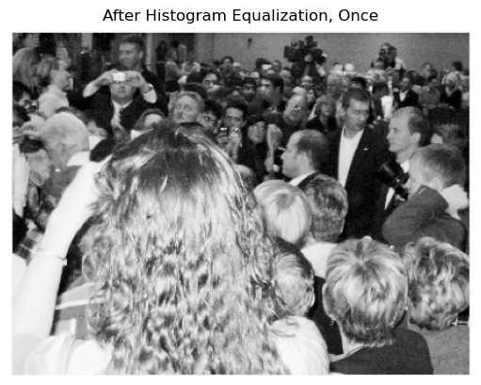 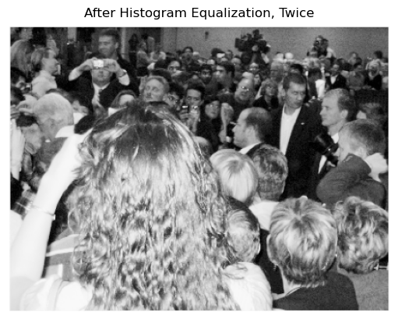

As shown in the comparison, there is no noticeable change when Histogram Equalization is applied on an already equalized image. The method enhances the contrast of the image at the very first time. There is no improvement if applied again to the image. There maybe adverse effects, like saturation, if applied again.

PDFs:

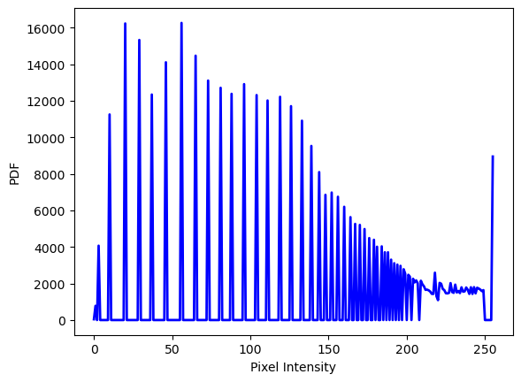 

CDFs:

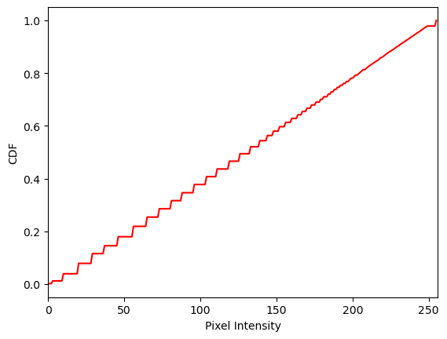 

Furthermore, the CDFs and PDFs of the respective images show no difference. From this, we can say that there is no impending adverse effects.

1. **Apply histogram equalization to your own low contrast image (greyscale). Show and discuss the results.**

**New Image:** **Histogram Equalized Image:**

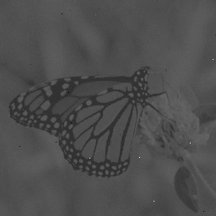 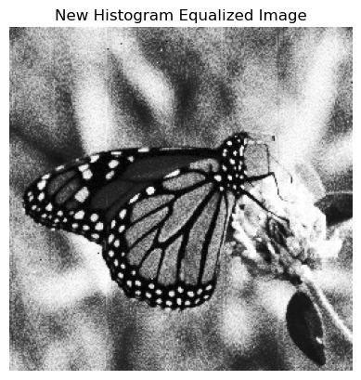

PDFs:

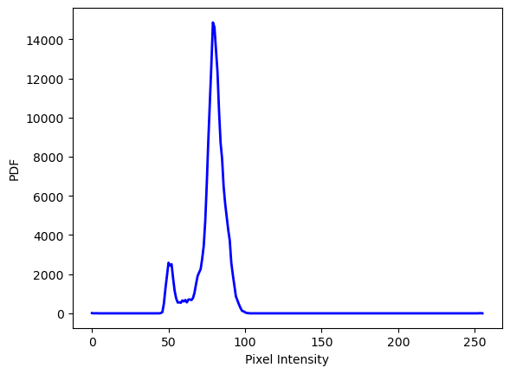 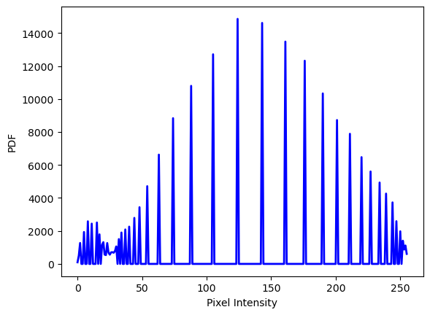

CDFs:

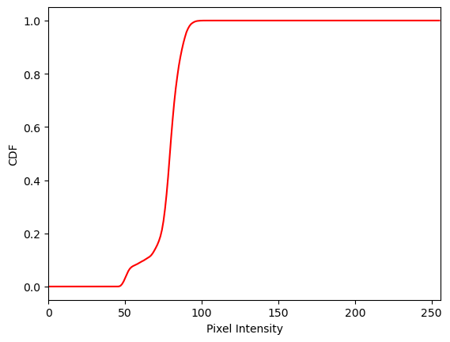 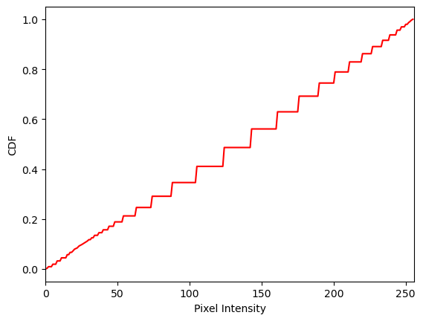

The input low contrast image, considering the PDF, has a lot of pixels within the intensity range 60 – 100 and very less to nil in the remaining range. Considering the CDF, there is a steep increasing slope in the same pixel intensity range, 60 – 100. This means that the image is not definite in terms of pixel distribution across the intensity range.

Upon applying the histogram equalization on the low contrast grayscale image, we can see an evident change in the contrast. There is a noticeable change in the PDF and CDF of the enhanced image. There are multiple spikes and valleys in the PDF, which says that the pixel distribution is performed definitely across the pixel intensity range. Because of this, the CDF has an evident and a periodical increase in the slope. Comparatively, the CDF is linear in the enhanced image. This means that the pixels are distributed across the pixel intensity range equally. The intensity level has an approximately equal probability.

### A2) Otsu Image Thresholding

**Image “b2_a.png”**

1. **Show the histograms for each image**

Image “b2_a.png” and corresponding Histogram

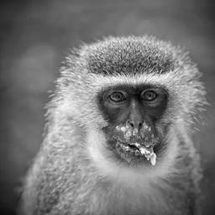

The image above is the unenhanced image using Otsu Thresholding method. The given PDF (histogram) of this image has multiple pixel intensities with various frequencies at each intensity level. It is seen that the frequencies have not been normalized or any threshold is used at any point.

1. **Generate a plot of the inter-class variance as a function of the chosen threshold (i.e., x-axis with each possible threshold from 0-255, y-axis with the resulting variance)**

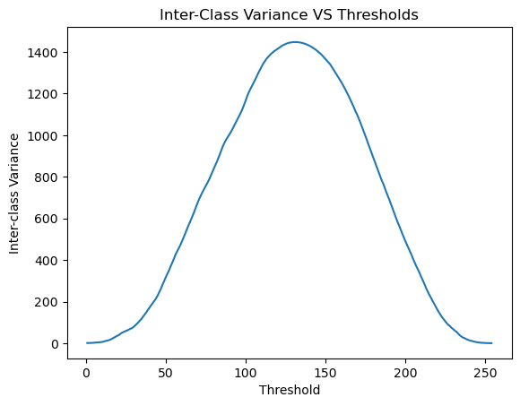

The image depicts a plot between the inter-class variance and the pixel intensity. There are a total of 256 possibilities of threshold. At each intensity level threshold, the inter-class variance is calculated and plotted to check for the maximum inter-class variance. As the plot shows, an estimation of the maximum inter-class variance is found at around 1400.

1. **State the inter-class variance of the image upon completion of the algorithm**

The inter-class variance is **1448.0136**. As estimated, the maximum inter-class variance is found to be 1448.0136. So, the threshold to be chosen is the value at which the inter-class variance is at its maximum.

1. **Note the intensity threshold chosen by the algorithm**

Threshold chosen by the algorithm is at **131-pixel intensity.** The precise intensity level that attained the maximum inter-class variance is 131.

1. **Show the resulting binary image produced by the algorithm**

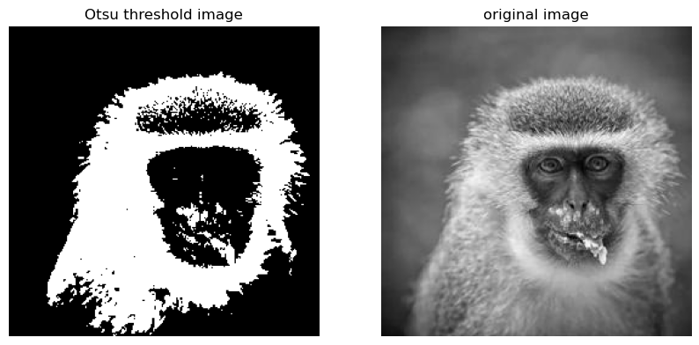 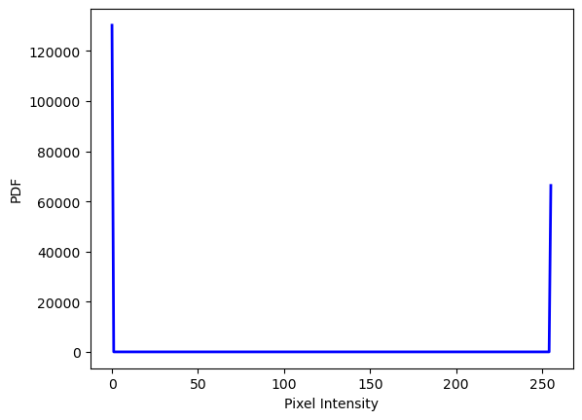

Once the thresholding is done, the pixel intensities are narrowed down to two values alone. 0 and 255 alone, that is, white and black. A binary image is created with a threshold of 131. That is, any pixel intensity greater than 131 is considered as black, that is, that value is changed to 255. Similarly, any intensity lesser than 131 is considered as white, that is, that value is changed to 0.

**Image “b2_b.png”**

1. **Show the histograms for each image**

Image “b2_b.png” and corresponding Histogram

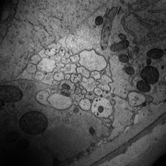

The above is the image before using Otsu Thresholding method. The given PDF (histogram) of this image has multiple pixel intensities with various frequencies at each intensity level. It is seen that the frequencies have not been normalized or any threshold is used at any point.

1. **Generate a plot of the inter-class variance as a function of the chosen threshold (i.e., x-axis with each possible threshold from 0-255, y-axis with the resulting variance).**

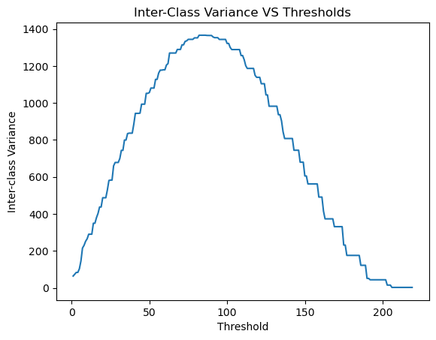

The image depicts a plot between the inter-class variance and the pixel intensity. There are a total of 256 possibilities of threshold. At each intensity level threshold, the inter-class variance is calculated and plotted to check for the maximum inter-class variance. As the plot shows, an estimation of the maximum inter-class variance is found between 1200 and 1400.

1. **State the inter-class variance of the image upon completion of the algorithm**

The inter-class variance is **1366.6478**. As estimated, the maximum inter-class variance is found to be 1366.6478. So, the threshold to be chosen is the value at which the inter-class variance is at its maximum.

1. **Note the intensity threshold chosen by the algorithm**

Threshold chosen by the algorithm is at **85-pixel intensity.** The precise intensity level that attained the maximum inter-class variance is 85.

1. **Show the resulting binary image produced by the algorithm**

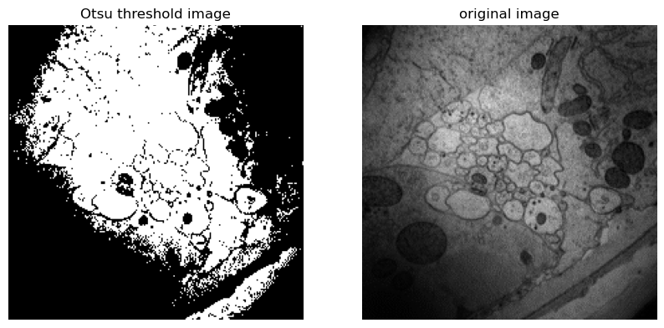 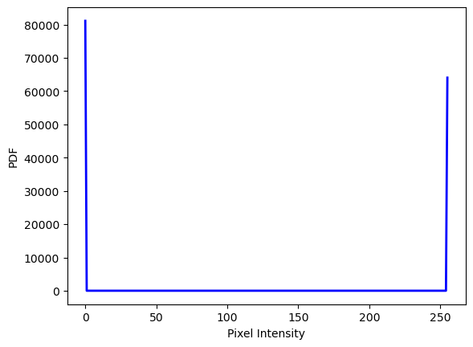

Once the thresholding is done, the pixel intensities are narrowed down to two values alone. 0 and 255 alone, that is, white and black. A binary image is created with a threshold of 85. That is, any pixel intensity greater than 85 is considered as black, that is, that value is changed to 255. Similarly, any intensity lesser than 85 is considered as white, that is, that value is changed to 0.

**Image “b2_c.png”**

1. **Show the histograms for each image**

Image “b2_c.png” and corresponding Histogram

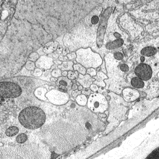

The above is the image before using Otsu Thresholding method. The given PDF (histogram) of this image has multiple pixel intensities with various frequencies at each intensity level. It is seen that the frequencies have not been normalized or any threshold is used at any point.

1. **Generate a plot of the inter-class variance as a function of the chosen threshold (i.e., x-axis with each possible threshold from 0-255, y-axis with the resulting variance).**

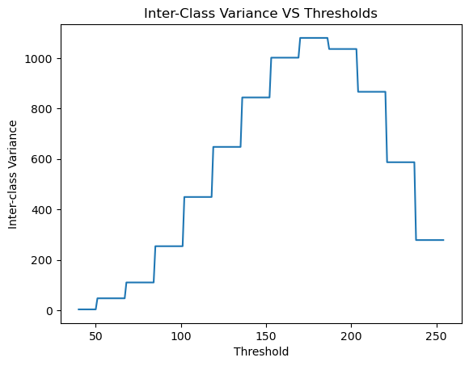

The image depicts a plot between the inter-class variance and the pixel intensity. There are a total of 256 possibilities of threshold. At each intensity level threshold, the inter-class variance is calculated and plotted to check for the maximum inter-class variance. As the plot shows, an estimation of the maximum inter-class variance is found to be more than 1000.

1. **State the inter-class variance of the image upon completion of the algorithm**

The inter-class variance is **1079.7087**. As estimated, the maximum inter-class variance is found to be 1079.7087. So, the threshold to be chosen is the value at which the inter-class variance is at its maximum.

1. **Note the intensity threshold chosen by the algorithm**

Threshold chosen by the algorithm is at **170-pixel intensity.** The precise intensity level that attained the maximum inter-class variance is 170.

1. **Show the resulting binary image produced by the algorithm**

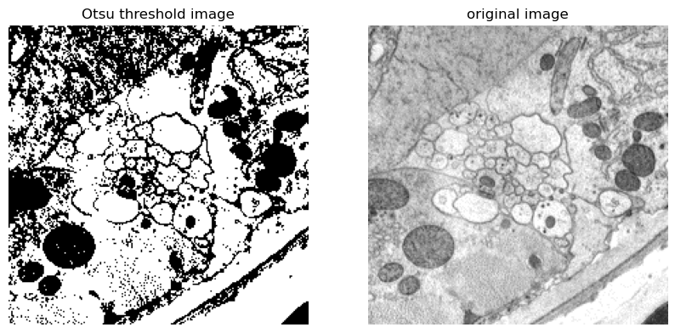 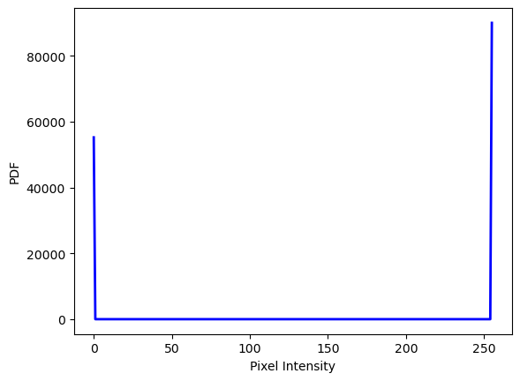

Once the thresholding is done, the pixel intensities are narrowed down to two values alone. 0 and 255 alone, that is, white and black. A binary image is created with a threshold of 170. That is, any pixel intensity greater than 170 is considered as black, that is, that value is changed to 255. Similarly, any intensity lesser than 170 is considered as white, that is, that value is changed to 0.

1. **Results:**

Otsu Threshold using CV2:

Using cv2’s inbuilt method for otsu thresholding, the threshold value at which the inter-class variance is maximum is computed. The results are just the same as we derived upon from the hard coded Otsu thresholding.

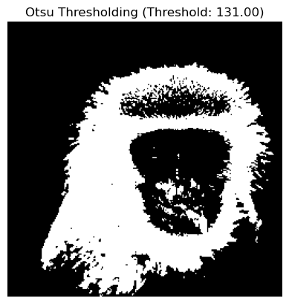 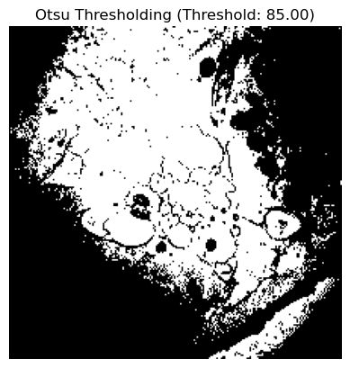

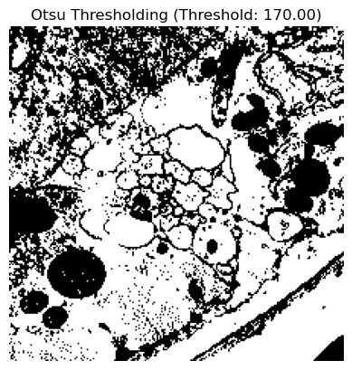

Manual Thresholding:

Unlike Otsu Thresholding, manual thresholding needs a manual comparison of the maximum inter-class variance and the respective threshold among the pixel intensities. Manual thresholding demands manual comparisons unlike Otsu threshold.

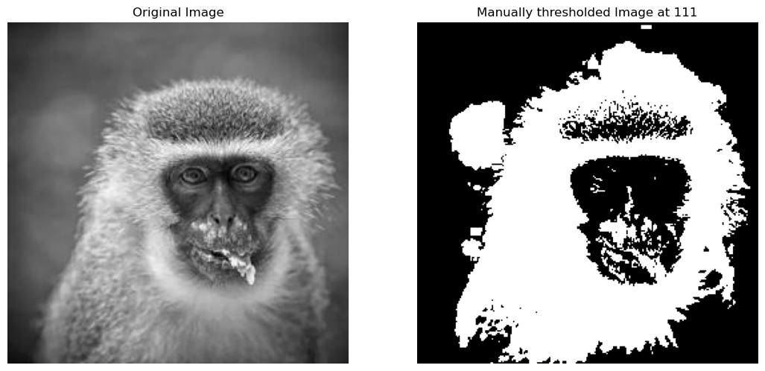

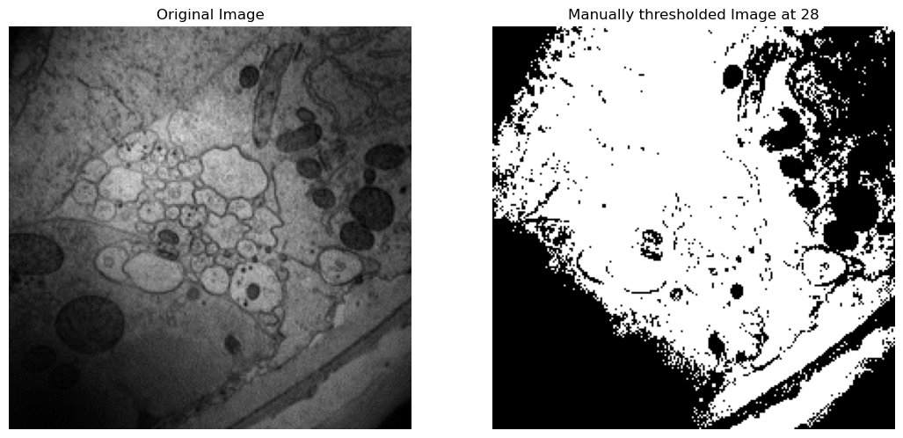

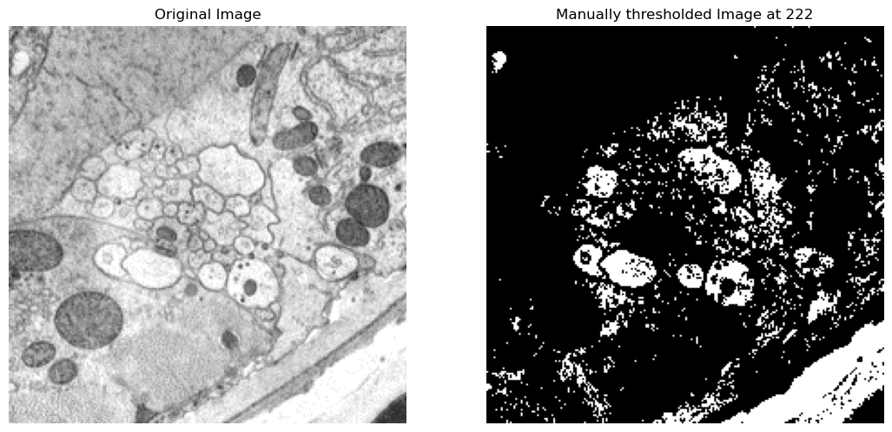

Considering the results from the Otsu Thresholding process and Manual Thresholding process, Otsu Thresholding yields better results and least manual struggle with a guaranteed result for the threshold value where the inter-class variance is maximum.

|  |  |  |  |
| --- | --- | --- | --- |
| Image | Otsu threshold | Otsu Threshold CV2 | Manual Threshold |
| b2_a | 131 | 131 | 111 |
| b2_b | 85 | 85 | 28 |
| b2_c | 170 | 170 | 222 |

### A3) Creative Part

**Histogram matching: Instead of histogram equalization, we can choose a source image (to be  
improved) and a target image (with good contrast). Implement histogram matching (discussed on the last page of the hand-written notes on histogram analysis. Test how this works with a target image of similar scene content, or with an image from a completely different scene.**

**Histogram Matching**: This process is used to take a reference of a target image and change the input image’s contrast. The update of the input image’s contrast solely depends on the contrast level of the target image’s contrast levels. With the help of this process, we can either increase the contrast or decrease as well. The methodology is very practical. It creates a new histogram that tends to be similar to the target image’s histogram and generates the image from the derived histogram values.

Delving deeper into the methodology, it calculates the difference between cumulative density function of the target image and that of the input image at the intensity level of the chosen pixel. Then chooses the minimum of the absolute differences computed earlier. Creating a new image, the resultant value is then assigned to the respective pixel of the new image that is to be formed. Mapping of the pixel intensity from the input image to the new image that better matches the target image’s histogram.

Finally, a new image is generated that has the contrast and the histogram similar to the target image.

**Experiments:**

1. **High Contrast Image to Low Contrast Image:**

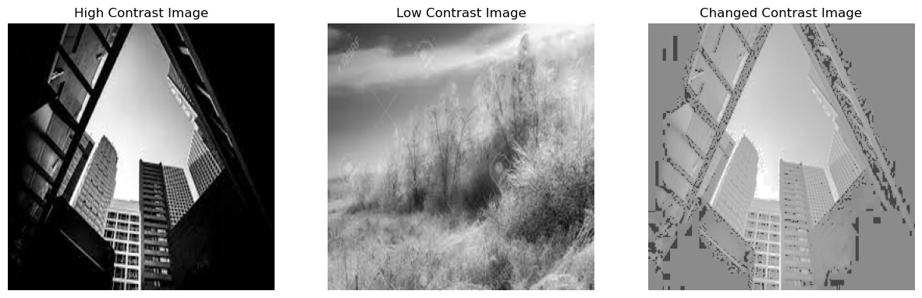 

High Contrast Image Histogram Low Contrast Image Histogram

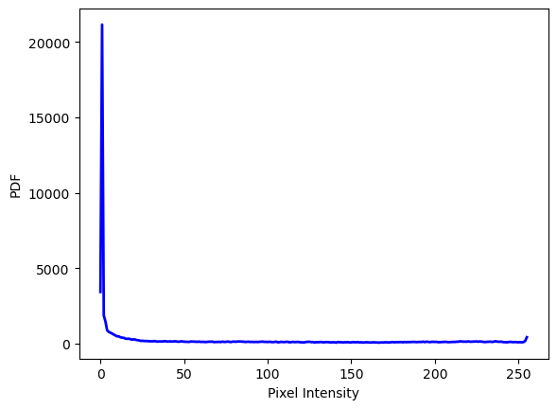 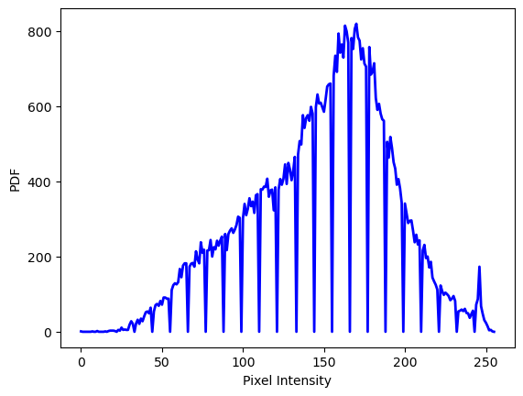

Resulting Image:

 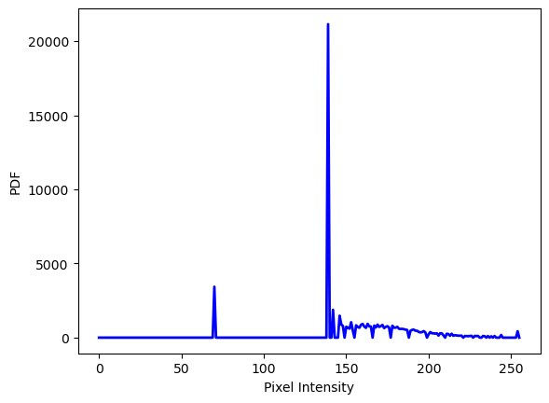

As seen, the histogram shows more frequency in the range of 100 – 150-pixel intensity, similar to the target image (low contrast image). Originally, the input image has all the pixels concentrated on the darker side. Once the histogram is matched, the pixels are normalized and brought to the frequent intensities that similar to the target image’s intensities.

1. **Low Contrast Image to High contrast Image:**

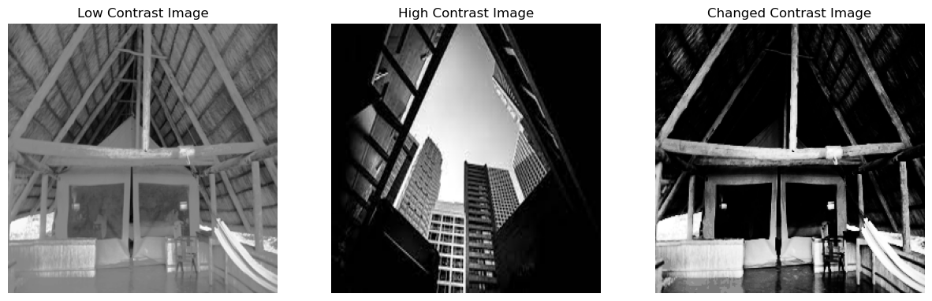 

Low Contrast Image Histogram High Contrast Image Histogram

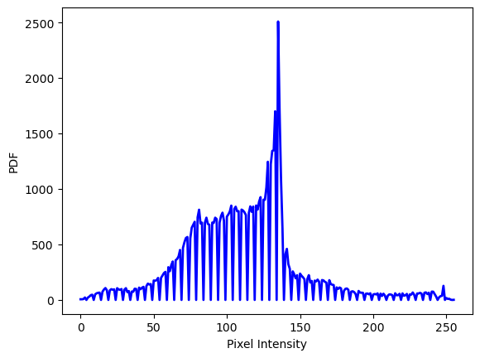 

Resulting Image:

 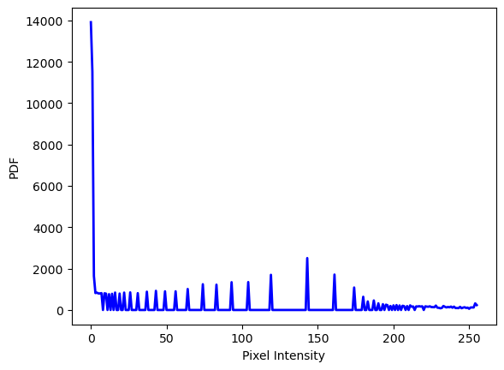

As seen, the histogram shows more frequency in the range of 0 - 10-pixel intensity, similar to the target image (high contrast image). Originally, the input image has all the pixels concentrated in the middle region of the intensity spread. Once the histogram is matched, the pixels are normalized and brought to the frequent intensities that similar to the target image’s intensities, that is in the range of 0 – 15-pixel intensity.